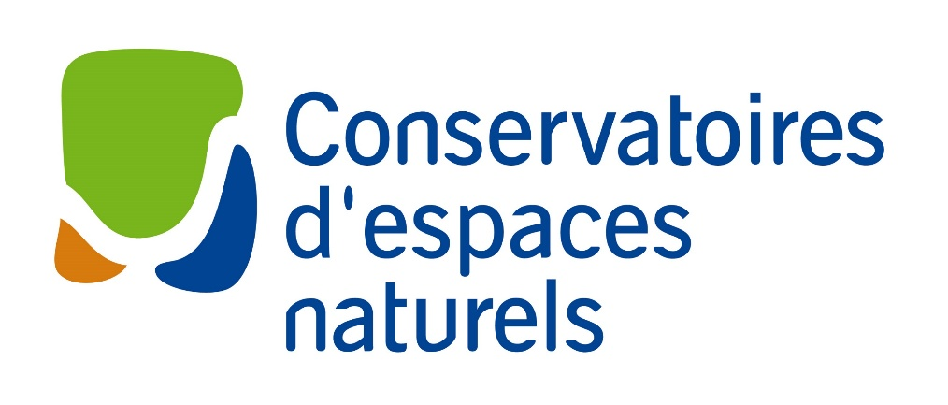

CALL FOR PROPOSALS – TWINNING PROJECTS
Application form
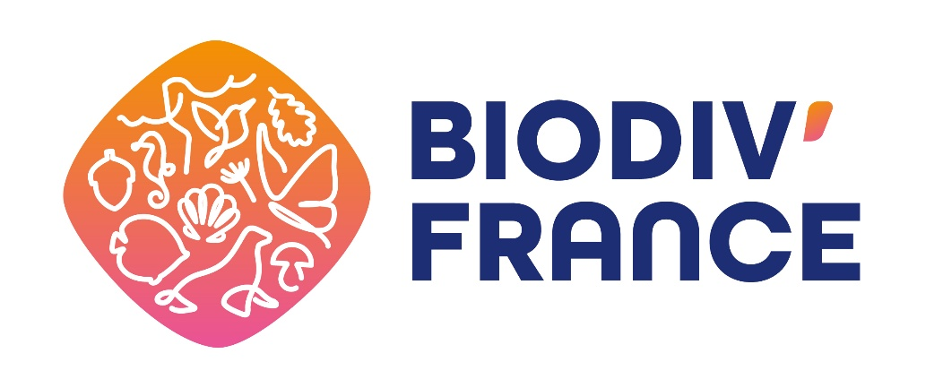

MANAGER N°1
Complete name of the organisation

Status of the organisation

N° of enterprise identification in the current national system (SIREN number in France)

Complete name of the legal representative

Address of the headquarters

Date of establishment of the organisation

Website

Short description of the organisation’s activities

Existing international cooperation strategies
Yes/No. To attach as supporting documents

Complete name of the person who will be in charge of the twinning project

Title of the office

Contact details (email address and phone number, with the designator +33 for France)

Name(s) of the site(s) concerned by the twinning project

Location(s) of the site(s) concerned by the twinning project
To attach: local and regional mapping and scale

Biogeographical region of the site(s)
Atlantic, continental, alpine, mediterranean or intertropical

Ecosystem(s) of the site(s)

Natura 2000 site(s)
If applicable, please provide the full name of (each) site, including the site code. Also indicate whether the site is fully or partially included in the twinning project, i.e. whether it is one of the locations of the joint activities

Level and status of protection of the site(s)
Statutory protection, contractual, voluntary, land ownership…

Management plan(s)
Type of document(s) and periodicity

Photographs
2-5 photos and credits

MANAGER N°2
Country

Complete name of the organisation

Status of the organisation

N° of enterprise identification in the current national system

Complete name of the legal representative

Address of the headquarters

Date of establishment of the organisation

Website

Short description of the organisation’s activities

Existing international cooperation strategies
Yes/No. To attach as supporting documents

Complete name of the person who will be in charge of the twinning project
Title of the office

Contact details (email address and phone number, with the international designator)

Name(s) of the site(s) concerned by the twinning project

Location(s) of the site(s) concerned by the twinning project
To attach: local and regional mapping and scale

Biogeographical region of the site(s)
Atlantic, continental, alpine, mediterranean or intertropical

Ecosystem(s) of the site(s)

Natura 2000 site(s)
If applicable, please provide the full name of (each) site, including the site code. Also indicate whether the site is fully or partially included in the twinning project, i.e. whether it is one of the locations of the joint activities

Level and status of protection of the site(s)
Statutory protection, contractual, voluntary, land ownership…

Management plan(s)
Type of document(s) and periodicity

Photographs
2-5 photos and credits

COMMON TWINNING PROJECT
Project title

If exist, the nature of the preexisting relationships between the organisations

Description of the project and the planned joint actions

Goals

Identified benefits for both managers

Indicators of the success of the project
At least three qualitative and/or quantitative indicators
Examples: number of meetings, survey on the impacts of the project, tools to evaluate communication campaign visibility, participant interviews, …

Projected timetable

Reliability of the perennation plan and sustainability of the project

STUDY FIELD TRIP N°1
Planned date

Planned place

Goals and benefits of the study field trip

Provisional planning and main stakeholders to meet

People participating in the study field trip
Organisations/stakeholder groups and interest in participating. If known, identity and office of the people

Means of transport
Preferential criterion if not air transport

STUDY FIELD TRIP N°2
Planned date

Planned place

Goals and benefits of the study field trip

Provisional planning and main stakeholders to meet

People participating in the study field trip
Organisations/stakeholder groups and interest in participating. If known, identity and office of the people

Means of transport
Preferential criterion if not air transport

DRAFT BUDGET
Total of the demanded subsidy
Between €10.000 and €38.000 per twinning project

Detailed draft budget
 |  | Manager n°1: name
 |  | STAFF COSTS
 |  | Name | Hour cost | Nbr of hours | Cost (1)
 |  | 1
 |  | 2
 |  | 3
 |  | Total STAFF COSTS
 |  | MISSION EXPENSES
 |  | Type | Unit cost | Number | Cost (1)
 |  | 1
 |  | 2
 |  | 3
 |  | 4
 |  | 5
 |  | Total MISSION EXPENSES
 |  | EXTERNAL SPECIFIC EXPENDITURES
 |  | Type | Unit cost | Number | Cost (1)
 |  | 1
 |  | 2
 |  | 3
 |  | 4
 |  | 5
 |  | Total EXTERNAL SPECIFIC EXPENDITURES
 |  | GENERAL FEES
 |  | 7% of direct costs (staff + mission expenses + external specific expenditures)
 |  | Cost (1):
 |  | Total COSTS
 |  | - Costs must be indicated with all taxes included if you are not submitted to VAT, otherwise excluding taxes
 |  | Demanded subsidy (2)
 |  | Total* funder 1 (NAME)
 |  | Total* funder 2 (NAME)
 |  | Total* funder 3 (NAME)
 |  | Total FUNDING
*Potential or vested
(2) from €5.000 to €19.000 per organisation = total from €10.000 to €38.000 for the twinning project
 |  | Manager n°2: name
 |  | STAFF COSTS
 |  | Name | Hour cost | Nbr of hours | Cost (1)
 |  | 1
 |  | 2
 |  | 3
 |  | Total STAFF COSTS
 |  | MISSION EXPENSES
 |  | Type | Unit cost | Number | Cost (1)
 |  | 1
 |  | 2
 |  | 3
 |  | 4
 |  | 5
 |  | Total MISSION EXPENSES
 |  | EXTERNAL SPECIFIC EXPENDITURES
 |  | Type | Unit cost | Number | Cost (1)
 |  | 1
 |  | 2
 |  | 3
 |  | 4
 |  | 5
 |  | Total EXTERNAL SPECIFIC EXPENDITURES
 |  | GENERAL FEES
 |  | 7% of direct costs (staff + mission expenses + external specific expenditures)
 |  | Cost (1):
 |  | Total COSTS
 |  | - Costs must be indicated with all taxes included if you are not submitted to VAT, otherwise excluding taxes
 |  | Demanded subsidy (2)
 |  | Total* funder 1 (NAME)
 |  | Total* funder 2 (NAME)
 |  | Total* funder 3 (NAME)
 |  | Total FUNDING
*Potential or vested
(2) from €5.000 to €19.000 per organisation = total from €10.000 to €38.000 for the twinning project

